
Probe Audit Premium+


Probe Review


Probe Compilation

What’s new 2025.20.13

Index

1. Caseware Working Papers 2025.00.091 (Release 2) 4
1.1 Features 4
1.2 Fixes and improvements 5
2. Universal 6
2.1 Features 6
2.1.1 License management 6
2.1.2 Engagement Optimisation 6
2.2 Fixes and improvements 7
2.2.1 02.40 – Conclusion cells for totals 7
2.3 Previously reported items fixed with Hotfixes 7
2.3.1 Hidden procedures 7
2.3.2 02.50 - Considerations of assurance report 7
3. Audit 8
3.1 Compliance Update 8
3.1.1 Companies Act Changes (South African entities only) 8
3.2 Features 8
3.2.1 10 51 - Probe Optimiser 8
3.3 Fixes and improvements 10
3.3.1 11.60 - Qualitative material assessment of sections 10
3.3.2 Information produced by the entity (IPE) 11
3.3.3 Information technology general and application controls 12
3.3.4 02.60 - Modification of working papers after audit report date 13
3.3.5 Group Audits: Impact of eliminating journal entries on prelim balances 13
3.3.6 Group Audits: 10.51 and 10.50G - Inclusion of manually enabled sections 13
3.3.7 10.51 - Use of service organisations 14
3.3.8 Group Audits: 10.53 – Estimates 14
3.3.9 Group Audits: 11.20G - Text wrapping on name of entity or business unit 14
3.3.10 11.60 - Blank risks identified 14
3.3.11 12.10 - Manager planning checklist 14
3.3.12 Group Audits: 12.23G - Component materiality 14
3.3.13 Automation of evidence prepared by management’s expert 14
3.3.14 02.00 - Work program conclusions 14
3.3.15 02.92 - Financial instruments 14
3.4 Previously reported items fixed with Hotfixes 15
3.4.1 Work programs 15
3.4.2 10.30 - Companies Act procedures 15
3.5 Firm Author Notice 15
3.5.1 Prior to Update to 2025.20.13 15
3.5.2 Prior to Repackaging of Template for Distribution 15
4. Review 16
4.1 Fixes and improvements 16
4.1.1 SME Sections on 10.70 16
4.2 Previously reported items fixed with Hotfixes 16
4.2.1 15.10 – Focused enquiries working paper 16
4.3 Known matters 16
4.3.1 10.70 – Blank LTBMs identified 16
5. Compilation 17
5.1 Fixes and improvements 17
5.1.1 06.50 Gathering compilation information 17
6. Updated document summary 18

Caseware Working Papers 2025.00.091 (Release 2)
The following describes the features and fixes included in Working Papers 2025 and related products.

Features
This release includes the following new features:

- Chromium Embedded Framework (CEF) has been updated to version 131 to stay in line with the latest updates.
- You can now export journal entry transfers to a format that is highly compatible with Xero, allowing for a more efficient import process.
- CSS is now supported when printing to the iXBRL file format.
- Installation - You will be required to fill in a username and email on installation.
- The copy existing section method lets you specify if you want to insert the existing section before or after the relative section.
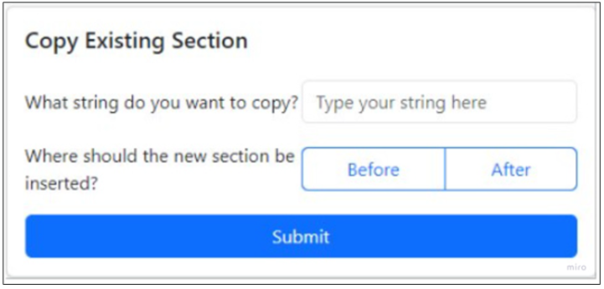
- The cloud installer lets you self-serve and generate a silent install.
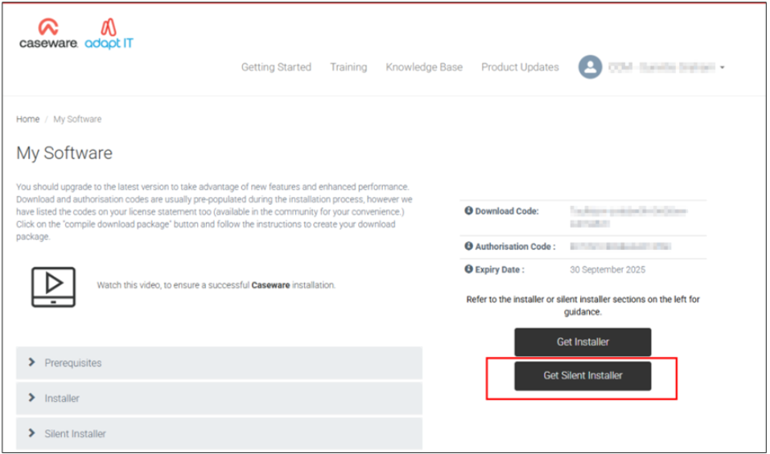

- The cloud installer now lets you add your customised firm template to the distributable for your firm.
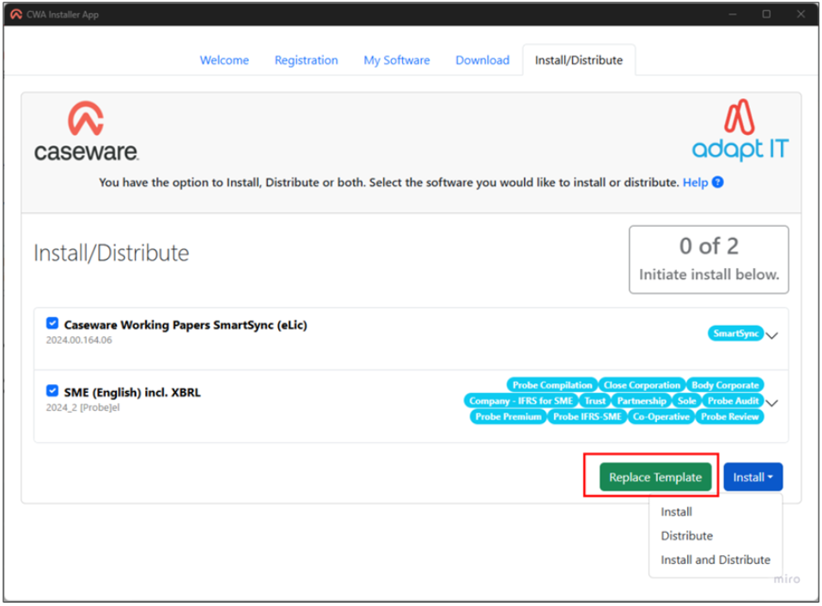

Fixes and improvements
This release includes fixes to the following issues:

- Published Working Papers engagements that are pending lockdown do not show the correct lockdown status (P) on Caseware Cloud.
- The document modification time does not account for time zone differences, resulting in erroneous sync conflicts.
- The multi-year view of the trial balance does not calculate prior year balances correctly.
- Caseware AiDA occasionally fails to summarize the active PDF document.
- A conversion error prevents Xero trial balance data from being imported into Working Papers.
- The CaseView calculation editor does not display ampersands correctly.
- Large values do not round correctly in certain graph types.
- CaseView documents open slower if the engagement is published to an on-premises SmartSync Server.

Universal

Features

License management
You now have control over who is using your licences. You can navigate to the licence assignment screen to see who is using your licences and you can allocate licences to specific users in the firm. Firms will be onboarded onto this feature with their 2026 licence renewals.

Engagement Optimisation
The Engagement Optimization is a newly introduced feature in Caseware Working Papers designed to enhance performance and streamline your workflow.

This feature automatically removes unnecessary documents from your Working Papers template, resulting in a more efficient roll forward process. By reducing the number of documents that need to be opened during roll forward, users will experience faster load times and improved responsiveness.

You can access this feature via the File > New from Existing wizard, as illustrated below:
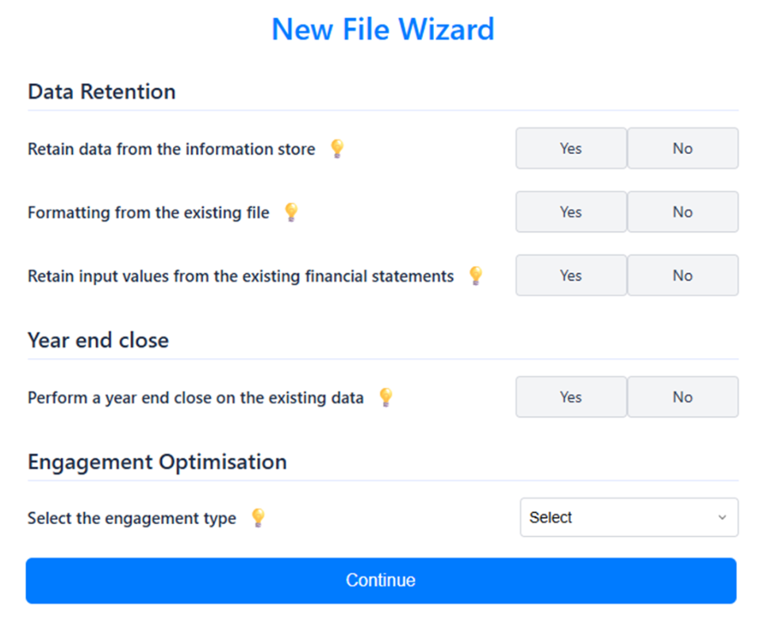

These are the options in the dropdown for engagement optimisation: 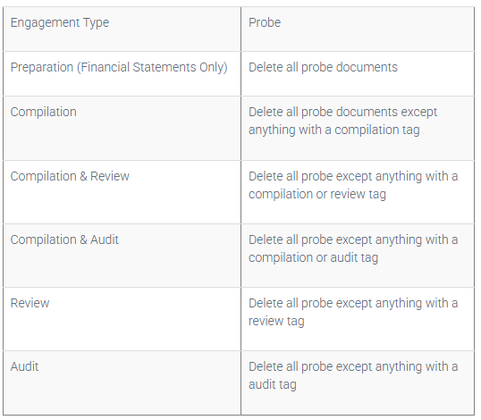

You will also have to answer the engagement optimisation question when you create a new file.
If you are creating a new file to prepare a firm template. Please follow the steps here to create a new file.

Fixes and improvements

02.40 – Conclusion cells for totals
Conclusions added for all total lines within the Evaluation of misstatements now retain.

Previously reported items fixed with Hotfixes
https://success.casewareafrica.com/articles/Knowledge/Probe-Hotfix
The following list briefly describes hotfixes which are now included in the templates:

Hidden procedures
This hotfix corrected an issue where hidden procedures, after being inserted, disappeared again when going back to default view.

02.50 - Considerations of assurance report
This hotfix corrected an issue where if IFRS for SMEs is selected as the accounting framework in 10.20, the question in 02.50 regarding fair presentation of the financial statements in accordance with the framework automatically pulls through as "No".

Audit

Compliance Update

Companies Act Changes (South African entities only)
This release includes changes related to the Companies Amendment Act 16 of 2024 (First Amendment Act) and the Companies Second Amendment Act 17 of 2024 (Second Amendment Act) signed into law on 26 July 2024. Certain sections of the First Amendment Act and the full Second Amendment Act came into effect on 27 December 2024.

The following changes were made to include relevant legislative changes.

Matter identified | Companies Act ref | Comment
10.50 Gathering information
Financial assistance | Section 71 | The financial assistance question includes the  exclusion of financial assistance provided to or for the  benefit of subsidiaries for financial periods ending after  27 December 2024.
10.51 Types and volumes of transactions
Financial assistance provided by the entity | Section 71 | The guidance to the financial assistance audit  considerations now includes the exclusion of financial  assistance provided to or for the benefit of subsidiaries  with an indication of the effective date.
FSA work programs: 340, 341, 347, 348, 350, 430, 449
Financial assistance | Section 71 | The guidance to the financial assistance audit  considerations now includes the exclusion of financial  assistance provided to or for the benefit of subsidiaries  with an indication of the effective date.
20.10 Laws and regulations
Public company – annual general meeting | Section  61(8) | Procedures are added to check that the appropriate  business is attended to at the annual general meeting of  public companies.  These procedures will appear when “Unlisted public  company” or “Listed company” is selected for  “Category of entities” in 10.20.
Social and ethics committee | 72 | Added a procedure related to the composition of the  social and ethics committee for financial periods ending  after 27 December 2024.

Features

10 51 - Probe Optimiser
Through the Probe Optimiser, users are now able to purge the content within work programs for sections that are not applicable to their audit engagements. This feature will increase speed and efficiently throughout the file.

The Probe Optimiser functions from document 10.51 – Types and volumes of transactions and only impacts the content within the work programs of the section being Optimised. The user will not be able to Optimise any sections where there is a prelim balance attached, the function is only available on sections where there is a nil prelim balance.

Once a change is made that affects 10.51, either by importing a trial balance or by manually enabling sections, a yellow bar warning will appear to trigger the users to run the Probe Optimiser.

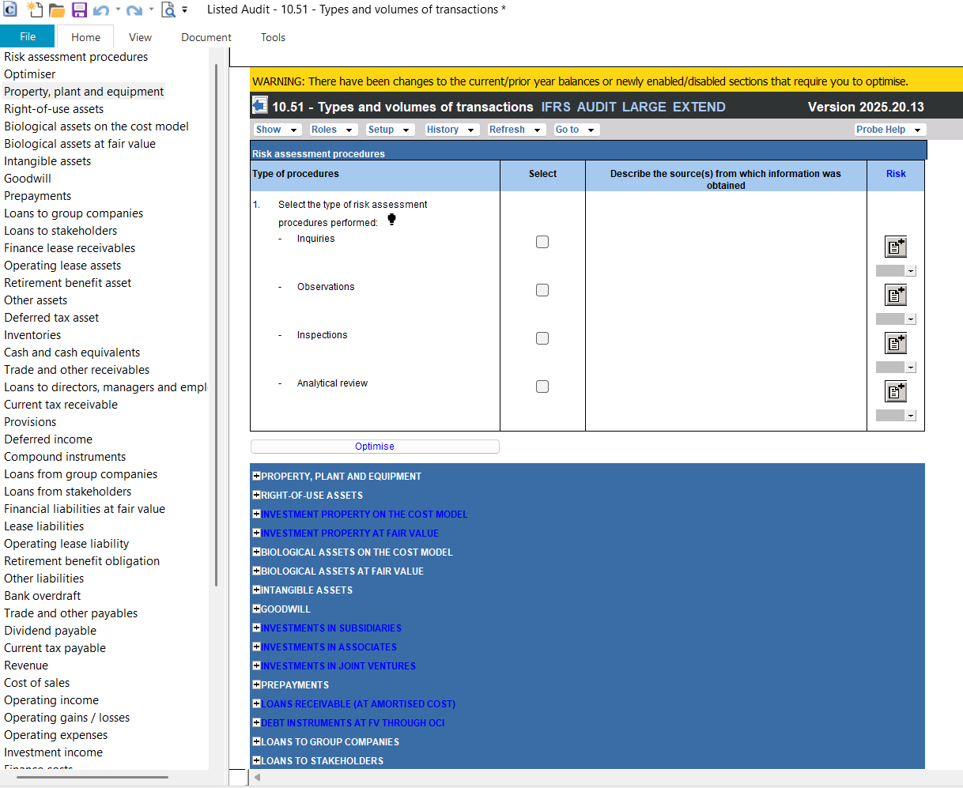

Once the Probe Optimiser has run, the content from the work program is removed, and the word “OPTIMISED” appears within the document name to alert the user that this work program has been impacted by the Probe Optimiser.
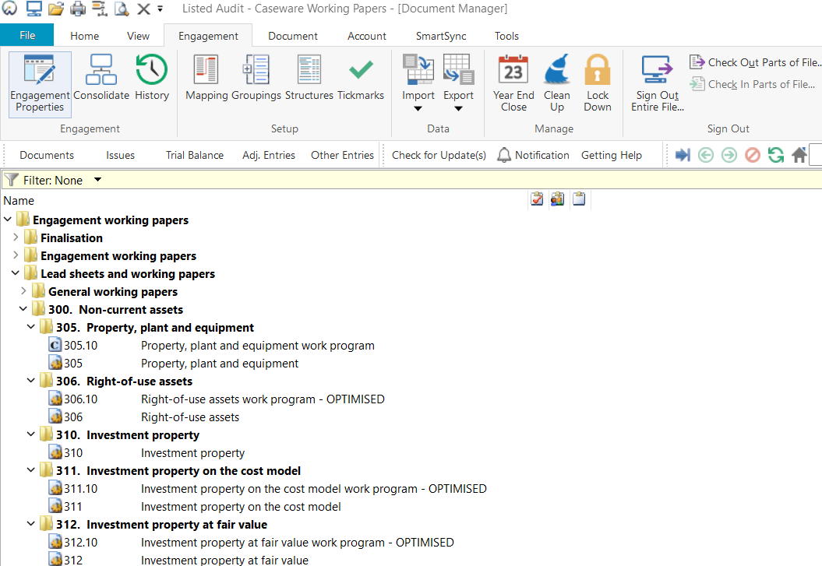

This content can be brought back at any point; the user will only need to manually enable the section in 10.51 and then run the Probe Optimiser again. The work programs for sections enabled will then be restored.

If changes are made to the prelim balances on the trial balance after initial import, the yellow bar warning will appear in every document to trigger the user to run the Probe Optimiser again, to ensure that all applicable sections are enabled/disabled where necessary.

In addition, the Probe Optimiser will take effect on Update, based on the framework selected in 10.20. Therefore, if the user is updating an IFRS engagement, all IFRS for SMEs specific sections will be Optimised on Update

Fixes and improvements

11.60 - Qualitative material assessment of sections
Users will now be able to assess sections as qualitative material on 11.60 – Risk assessment at assertion level, similar to how other disclosure items (e.g. related parties) are assessed when quantitative materiality cannot be determined from the preliminary trial balance.

When a section is not determined to be qualitative material, based on the preliminary trial balance and specific materiality of the section, a question will be included to determine whether the section is qualitatively material. When answered “Yes”, users will be prompted to document the reason for assessing the section as qualitatively material.
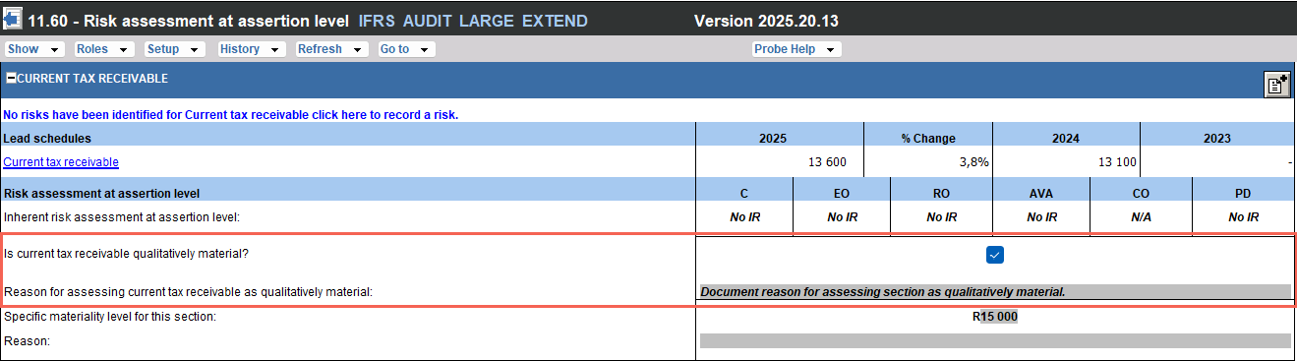

Users will also be prompted to consider whether a lower materiality threshold is appropriate for the relevant section, as required by ISA 320.10 and A2, which highlight that misstatement below overall materiality may influence the economic decisions of users.

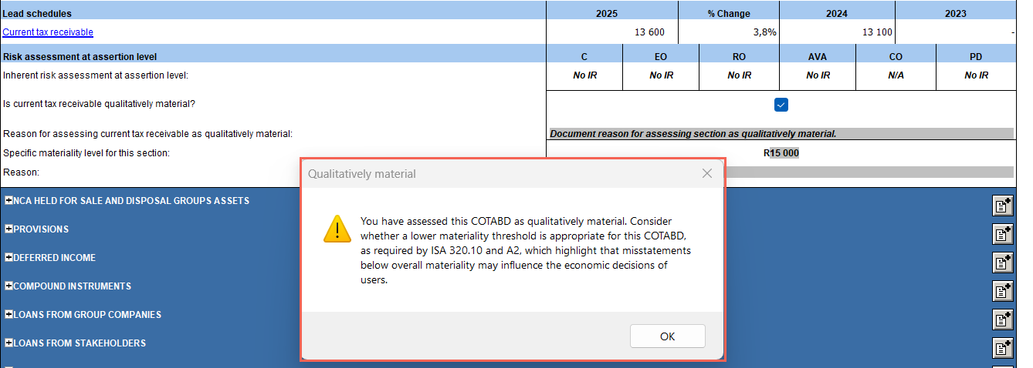

When assessed as qualitative material on 11.60, the section will be treated similarly to a quantitative material section, including:
- When an inherent risk has not been identified, and therefore the section is not determined to be a significant COTABD (SCOTABD), the red warning on 12.20 – Audit plan and strategy will prompt users to select at least one assertion for the material section in accordance with ISA 330 paragraph 18.
- The RoMM at the assertion level will be increased.

Information produced by the entity (IPE)
A common inspection finding by regulators is that audit documentation does not include sufficient evidence of testing the accuracy and completeness of system-generated information used as the basis for audit testing (e.g., revenue or journal entry populations). To help address this, the following improvements have been made:

Matter identified | ISA ref | Comment
10.50 Gathering information
Determine whether IPE will be used. | ISA 500.9 | A question has been added for the engagement team to  determine whether they will use IPE for:  - Planning (e.g. risk assessment), and  - Substantive procedures or tests of controls.
Testing the IPE to be used in planning. | ISA 500.9 | When IPE is selected for planning, a procedure is added  to test the accuracy and completeness of the IPE.
FSA Work programs
Testing the IPE to be used for tests of detail. | ISA 500.9 | When IPE is selected for substantive procedures or  tests of controls in 10.50, the work programs will include  procedures to test the accuracy and completeness of  the IPE.

Information technology general and application controls
Another common inspection finding by regulators is that engagement teams place inappropriate reliance on application controls by failing to test supporting IT general controls (ITGC). Engagement teams apply a control-based audit approach without a proper ITGC foundation, leading to insufficient audit evidence.

When ITGCs are identified in accordance with ISA 315 (Revised) paragraph 26(b) and (c) because they support the operating effectiveness of automated controls or the integrity of information used in financial reporting (including system-generated reports), it is necessary under ISA 330.10(b) to obtain audit evidence on the effective operation of those ITGCs (i.e., indirect controls).

In the previous market versions, users were required to
- Obtain an understanding of the IT environment (10.55).
- Determine whether controls that address significant risks, or controls on which the engagement team intends to place reliance, are IT-dependent or automated (11.50 - Information system and control activities).
- Identify IT-related risks arising from the IT applications and identify ITGC for the identified IT-related risks (11.50). Test the identified ITGCs (19.10 - General IT controls work program), if reliance on ITGCs is intended.

To address these inspection findings, new conclusion procedures and questions have been added to reinforce that reliance on application controls must be supported by an appropriate ITGC foundation.

Matter identified | ISA ref | Comment
11.50 Information system and control activities
Overall conclusion | ISA  315.26(b)  and (c) | A conclusion procedure now requires  users to evaluate intended reliance on IT  dependent or automated controls in the  context of intended reliance on ITGCs.  The procedure will be included when users  identify that controls addressing significant  risks or controls on which reliance is  intended, are dependent on IT applications  or other aspects of the IT environment  (i.e. IT IT-dependent) or automated.
19.10 General IT controls work program
Conclusion | ISA  330.10(b)  read with  A32 | A new conclusion question requires  consideration of whether ITGC deficiencies  may impact the effective operations of IT  dependent or automated controls  (i.e. application controls).  When deficiencies are identified, users are  prompted to revisit the decision to test the  operating effectiveness of IT-dependent or  automated controls.
12.20 Audit plan and strategy
Conclusion | ISA  330.10(b)  read with  A32 | A new conclusion question requires users  to determine whether the ITGC test results  provide sufficient evidence to support  reliance on IT-dependent or automated  controls (i.e. application controls).  The question will appear when reliance on  ITGCs has been identified on 11.50.  If answered “No”, users will be prompted to  revisit the decision to test the operating  effectiveness of IT-dependent or  automated controls where reliance on  controls was intended for any section.
FSA Work programs
Conclusion | ISA  330.10(b)  read with  A32 | A new conclusion question requires users  to determine whether any deficiencies in  the IT-dependent or automated controls  (i.e. application controls) cast doubt on the  operational effectiveness of ITGCs.  If answered “Yes”, users will be prompted  to consider the impact on the overall audit  approach.

02.60 - Modification of working papers after audit report date
Another common inspection finding is the lack of documented audit evidence or explanations for working papers created or modified after the audit report date (ISA 230.13). To reinforce compliance with ISA 230.13, questions were added to 02.60 - Senior’s final checklist to determine whether:
- New or additional audit procedures were performed, or new conclusions drawn after the auditor’s report date.
- Changes were made to the audit documentation, other than administrative, after the auditor’s report date.

If answered “Yes”, users are prompted to document the circumstances, procedures performed, evidence obtained, conclusions reached, report impact, and preparer/reviewer details.

Group Audits: Impact of eliminating journal entries on prelim balances
Users wanting to assess planning based on consolidated figures, after taking into account any eliminating journal entries, are now able to do this either by making use of the consolidation function within CWWP, or by importing the consolidated trial balance and passing eliminating journals.

For users making use of the consolidation function within CWWP for the first time, please ensure you familiarise yourself with the following related article on how to set up a consolidation/group file.

The impact of the eliminating journal entries will be taken into account for all Probe Audit planning documents, where prelim balances are used. There has been no change to any other type of journal entries.

Group Audits: 10.51 and 10.50G - Inclusion of manually enabled sections
For Group Audit M, on 10.51 – Types and volumes of transactions, users are now able to complete the ‘Transactions and balances’ for all manually enabled sections. Furthermore, all manually enabled sections will also be included in document 10.50G – Plan extent of risk assessment procedures for users to plan the extent of risk assessment procedures for those sections.

10.51 - Use of service organisations
When users indicate in 10.50 - Gathering of information that the entity uses services provided by a service organisation, they are now able to select in 10.51 -Types and volumes of transactions that service organisations apply to the disclosure sections. These include related parties, commitment and contingencies, statement of cash flows, other disclosure 1-3 and other area 1-3. These selections are made within ‘Transactions and balances’ of the section.

Group Audits: 10.53 – Estimates
For Group Audit M, changes have been made to when sections on 10.53 – Understanding of accounting estimates are enabled. Sections will be enabled when users select on 10.50G “Yes” to “Based on accounting estimate?” and then either “Yes” to “Consolidation balance only?” or “Yes” to “Plan to perform centrally?”. The section will then show on 10.53 for users to document their understanding of the accounting estimates.

Group Audits: 11.20G - Text wrapping on name of entity or business unit
For Group Audit M and S, on 11.20G – Identification of components and within the risk dialogue on 11.60 – Risk assessment at assertion level, the name of the entity or business unit now wraps to allow users to have sight of the full name up to 40 characters.

11.60 - Blank risks identified
When creating a new SME audit engagement for a single legal entity, 11.60 had an issue where two blank risks appeared under ‘Uncategorised risks”; this matter has been corrected.

12.10 - Manager planning checklist
The ISA220 procedure has been revised to include external experts and internal auditors to more clearly align with the ISA 220 requirements on the engagement team. Furthermore, the ISA 620 procedure has been reworded and will now always be included, and not only when the use of an expert is selected in 12.20.

Group Audits: 12.23G - Component materiality
For Group Audit M and S, users can now set component materiality for all components, irrespective of whether the component auditors will be used or not.

Automation of evidence prepared by management’s expert
The positive option on the procedure of evidence prepared by management’s expert on 12.20 – Audit plan and strategy now automatically pulls through to the use of expert's procedure in 12.30 – Planning memorandum. If users select “No” in 12.20, the procedure will not appear in 12.30.

02.00 - Work program conclusions
In the summary table in the Partner sign-off document, the comment section will only show for assertions where the estimated audit risk remaining and calculated audit risk remaining do not agree. Therefore, if an assertion has no ROMM attached, or the calculated and estimated audit risk remaining agrees, the comments will not appear within the work program conclusion table for that section.

02.92 - Financial instruments
A separate representation related to permissible offsetting of financial assets and liabilities is added for IFRS for SMEs.

Previously reported items fixed with Hotfixes
https://success.casewareafrica.com/articles/Knowledge/Probe-Hotfix
The following list briefly describes hotfixes which are now included in the templates:

Work programs
This hotfix corrected an issue where accounting estimates procedures remained hidden in the work programs even when selected in planning documents 10.50, 10.51 and 12.20.

10.30 - Companies Act procedures
This hotfix corrected an issue where the Companies Act procedures within document 10.30 remained hidden when the user has an Audit Large or Group Audit Large engagement file.

Firm Author Notice
The following list is applicable to all Firm Author’s as it pertains to changes in the Firm Template Authoring process with the introduction of the Probe Optimiser:

Prior to Update to 2025.20.13
Please ensure you have selected the correct framework in 10.20 (IFRS or IFRS for SMEs) and that you have enabled all sections within 10.51 before running the update to the 2025.20.13 template. This is to ensure that on Update, the Probe Optimiser does not Optimise out any sections applicable to your selected framework.

Prior to Repackaging of Template for Distribution
Please ensure that you have disabled all sections within 10.51 before repackaging your firm template for distribution. This will ensure that the Probe Optimiser works as expected on each individual engagement.

Review

Fixes and improvements

SME Sections on 10.70
Corrected the issue whereby certain SME sections were omitted on document 10.70.

Previously reported items fixed with Hotfixes
https://success.casewareafrica.com/articles/Knowledge/Probe-Hotfix
The following briefly describes a hotfix which is now included in the templates:

15.10 – Focused enquiries working paper
This hotfix corrected an issue where the cells in the Response column of each section randomly duplicated the documented information into other cells.

Known matters

10.70 – Blank LTBMs identified
10.70 has an issue where all newly created LTBMs are created twice. Once for the LTMB you recorded and a second one that appears as blank. You may delete the second one that shows as a blank risk.

Compilation

Fixes and improvements

06.50 Gathering compilation information
Corrected the issue whereby certain sections within document 06.50 were missing the default procedures.

Updated document summary
The following documents will work as follows on the update of firm templates from the previous market release as well as engagement files:

Number | Name | Type | Update in this version | Retain data | Retain some data
Firm template set-up
FIRMSETT | Probe Firm Settings | Checklist | a |  | a
Financial statements
Financial statement schedules and minutes
01.60 | Minutes | Letter |  |  | a
Compilation engagement
Finalisation
06.00 | Practitioner sign-off | Checklist |  | a
06.10 | Compilation letter of representation | Letter |  | a
Pre-engagement planning
06.20 | Compilation engagement evaluation | Checklist |  | a
06.21 | Compilation engagement letter | Letter |  | a
06.50 | Gathering compilation information | Checklist |  | a
Leadsheets and work programs
07.300 | Non-current assets compilation program | Work program |  | a
07.400 | Current assets compilation program | Work program |  | a
07.500 | Non-current liabilities compilation program | Work program |  | a
07.600 | Current liabilities compilation program | Work program |  | a
07.700 | Income and expenditure compilation program | Work program |  | a
07.800 | Equity compilation program | Work program |  | a
07.850 | Other disclosures compilation program | Work program |  | a
Engagement working papers
Finalisation
02.00 | Partner sign-off | Letter | a |  | a
02.05 | Engagement team declaration | Checklist |  |  | a
02.10 | Subsequent events work program | Checklist |  | a
02.20 | Going concern conclusion | Checklist | a | a
02.22 | Subordination agreement work program | Work program |  | a
02.30 | Overall analytical review | Letter | a |  | a
02.40 | Evaluation of misstatements | Checklist | a
02.50 | Consideration of assurance report | Checklist | a
02.55 | Key audit matters | Checklist |  | a
02.60 | Senior's final checklist | Checklist | a |  | a
02.70 | Manager's final checklist | Checklist | a |  | a
02.80 | Engagement Quality Review – Execution and finalisation | Checklist
Client communication
02.90 | Report to management and those charged with governance | Work program | a |  | a
02.92 | Letter of representation | Letter | a |  | a
Engagement working papers
Pre-engagement planning
10.20 | Engagement evaluation | Checklist | a | a
10.21 | Engagement letter | Letter
10.30 | Discussions with those charged with governance | Checklist | a | a
10.40 | Time budget | Letter |  | a
10.50 | Gathering information | Checklist | a | a
10.50G | Plan extent of risk assessment procedures | Checklist | a | a
10.51 | Types and volumes of transactions | Checklist | a |  | a
10.52 | Preliminary analytical review | Checklist | a | a
10.53 | Understanding of accounting estimates | Checklist | a | a
10.55 | Understanding the information Technology environment (IT) | Checklist | a | a
10.60 | Overall materiality assessment | Checklist | a | a
10.70 | Identify material items and areas likely to be misstated | Checklist | a | a
10.80 | Engagement Quality Review – Planning (Review) | Checklist |  | a
Planning and risk assessment procedures
11.10 | Risk analysis summary | Checklist | a | a
11.20 | Inherent risk assessment | Checklist | a | a
11.20G | Identification of components | Checklist | a | a
11.21 | Laws and regulations | Checklist |  | a
11.25 | Fraud risk assessment | Checklist | a | a
11.30 | Evaluation of system of internal control | Checklist |  | a
11.50 | Information system and control activities | Checklist | a | a
11.60 | Risk assessment at assertion level | Checklist | a | a
Audit planning
12.10 | Manager planning checklist | Checklist | a | a
12.20 | Audit plan and strategy | Checklist | a | a
12.20G | Further audit work at component level | Checklist | a | a
12.21 | Using internal audit | Checklist |  | a
12.22 | Use of resources | Checklist | a | a
12.22G | Use of component auditors | Checklist | a | a
12.23G | Component performance materiality | Checklist | a | a
12.26 | Use of another practitioner | Checklist |  | a
12.30 | Planning memorandum | Checklist | a | a
12.40 | Engagement Quality Review – Planning (Audit) | Checklist |  | a
Lead sheets and working papers
General working papers
15.10 | Focused enquiries working paper | Checklist | a | a
16.10 | Accounting records work program | Work program | a |  | a
17.10 | Opening balances and comparatives work program | Work program | a |  | a
18.10 | Financial statement preparation work program | Work program | a |  | a
19.10 | General IT controls work program | Work program | a |  | a
20.10 | Laws and regulations work program | Work program | a |  | a
25.10 | Consolidation process work program | Work program | a |  | a
26.10 | Evaluation of component auditor's work work program | Work program | a |  | a
300. Non-current assets
305. Property, plant, and equipment
305.10 | Property, plant and equipment work program | Work program | a |  | a
306. Right-of-use assets
306.10 | Right-of–use assets work program | Work program | a |  | a
311. Investment property on the cost model
311.10 | Investment property on the cost model work program | Work program | a |  | a
312. Investment property at fair value
312.10 | Investment property at fair value work program | Work program | a |  | a
316. Biological assets on the cost model
316.10 | Biological assets on the cost model work program | Work program | a |  | a
317. Biological assets at fair value
317.10 | Biological assets at fair value work program | Work program | a |  | a
320. Intangible assets
320.10 | Intangible assets work program | Work program | a |  | a
321. Goodwill
321.10 | Goodwill work program | Work program | a |  | a
326. Investments in subsidiaries
326.10 | Investments in subsidiaries work program | Work program | a |  | a
327. Investments in associates
327.10 | Investments in associates work program | Work program | a |  | a
328. Investments in joint ventures
328.10 | Investments in joint ventures work program | Work program | a |  | a
331. Prepayments
331.10 | Prepayments work program | Work program | a |  | a
340. Loans receivable (at amortised cost)
340.10 | Loans receivable (at amortised cost) work program | Work program | a |  | a
341. Debt instruments at FV through OCI
341.10 | Debt instruments at FV through OCI work program | Work program | a |  | a
347. Loans to group companies
347.10 | Loans to group companies work program | Work program | a |  | a
348. Loans to stakeholders
348.10 | Loans to stakeholders work program | Work program | a |  | a
350. Other financial assets
350.10 | Other financial assets work program | Work program | a |  | a
351. Investments at fair value
351.10 | Investments at fair value work program | Work program | a |  | a
352. Derivatives - asset
352.10 | Derivatives – asset work program | Work program | a |  | a
355. Finance lease receivables
355.10 | Finance lease receivables work program | Work program | a |  | a
356. Operating lease assets
356.10 | Operating lease assets work program | Work program | a |  | a
375. Contract assets
375.10 | Contract assets work program | Work program | a |  | a
376. Contract costs
376.10 | Contract costs work program | Work program | a |  | a
380. Retirement benefit asset
380.10 | Retirement benefit asset work program | Work program | a |  | a
390. Other assets
390.10 | Other assets work program | Work program | a |  | a
395. Deferred tax asset
395.10 | Deferred tax asset work program | Work program | a |  | a
396. Municipal deposits
396.10 | Municipal deposits work program | Work program | a |  | a
400. Current Assets
405. Inventories
405.10 | Inventories work program | Work program | a |  | a
405.11 | Attendance at physical inventory count work program | Work program | a |  | a
420. Cash and cash equivalents
420.10 | Cash and cash equivalents work program | Work program | a |  | a
420.11 | Cash count work program | Work program | a |  | a
430. Trade and other receivables
430.10 | Trade and other receivables work program | Work program | a |  | a
432. Construction contracts and receivables
432.10 | Construction contracts and receivables work program | Work program | a |  | a
449. Loans to directors, managers and employees
449.10 | Loans to directors, managers and employees work program | Work program | a |  | a
495. Current tax receivable
495.10 | Current tax receivable work program | Work program | a |  | a
499. NCA held for sale and disposal groups assets
499.10 | NCA held for sale and disposal groups asset work program | Work program | a |  | a
500. Non-current liabilities
515. Provisions
515.10 | Provisions work program | Work program | a |  | a
531. Deferred income
531.10 | Deferred income work program | Work program | a |  | a
542. Compound instruments
542.10 | Compound instruments work program | Work program | a |  | a
545. Redeemable members contributions
545.10 | Redeemable members contributions work program | Work program | a |  | a
547. Loans from group companies
547.10 | Loans from group companies work program | Work program | a |  | a
548. Loans from stakeholders
548.10 | Loans from stakeholders work program | Work program | a |  | a
550. Financial liabilities
550.10 | Financial liabilities work program | Work program | a |  | a
551. Borrowings
551.10 | Borrowings work program | Work program | a |  | a
552. Derivatives - liability
552.10 | Derivatives – liability work program | Work program | a |  | a
553. Financial guarantee contracts
553.10 | Financial guarantee contracts work program | Work program | a |  | a
555. Lease liabilities
555.10 | Lease liabilities work program | Work program | a |  | a
556. Operating lease liability
556.10 | Operating lease liability work program | Work program | a |  | a
575. Contract liabilities
575.10 | Contract liabilities work program | Work program | a |  | a
580. Retirement benefit obligation
580.10 | Retirement benefit obligation work program | Work program | a |  | a
590. Other liabilities
590.10 | Other liabilities work program | Work program | a |  | a
595. Deferred tax liability
595.10 | Deferred tax liability work program | Work program | a |  | a
600. Current liabilities
620. Bank overdraft
620.10 | Bank overdraft work program | Work program | a |  | a
630. Trade and other payables
630.10 | Trade and other payables work program | Work program | a |  | a
688. Dividend payable
688.10 | Dividend payable work program | Work program | a |  | a
695. Current tax payable
695.10 | Current tax payable work program | Work program | a |  | a
699. Liabilities of disposal groups
699.10 | Liabilities of disposal groups work program | Work program | a |  | a
700. Income statement
700. Revenue
700.10 | Revenue work program | Work program | a |  | a
720. Cost of sales
720.10 | Cost of sales work program | Work program | a |  | a
730. Operating income
730.10 | Operating income work program | Work program | a |  | a
741. Operating gains (losses)
741.10 | Operating gains (losses) work program | Work program | a |  | a
750. Operating expenses
750.11 | Wage payout work program | Work program | a |  | a
750.60 | Director's remuneration certificate | Work program | a |  | a
750.10 | Operating expenses work program | Work program | a |  | a
770. Investment income
770.10 | Investment income work program | Work program | a |  | a
775. Finance costs
775.10 | Finance costs work program | Work program | a |  | a
780. Non-operating gains (losses)
780.10 | Non-operating gains (losses) work program | Work program | a |  | a
781. Non-operating expenses
781.10 | Non-operating expenses work program | Work program | a |  | a
785. Non-operating income
785.10 | Non-operating income | Work program | a |  | a
790. Non-controlling interest - IS
790.10 | Non-controlling interest – IS work program | Work program | a |  | a
795. Taxation
795.10 | Taxation work program | Work program | a |  | a
797. Other comprehensive income
797.10 | Other comprehensive income work program | Work program | a |  | a
799. Discontinued operations
799.10 | Discontinued operations work program | Work program | a |  | a
800. Equity
805. Capital or contributions
805.10 | Capital or contributions work program | Work program | a |  | a
810. Retained income
810.10 | Retained income work program | Work program | a |  | a
820. Reserves
820.10 | Reserves work program | Work program | a |  | a
830. Non-controlling interest - BS
830.10 | Non-controlling interest – BS work program | Work program | a |  | a
850. Other disclosures
850. Related parties
850.10 | Related parties work program | Work program | a |  | a
857. Commitments and contingencies
857.10 | Commitments and contingencies work program | Work program | a |  | a
880. Statement of Cash Flows
880.10 | Statement of Cash Flows work program | Work program | a |  | a
891. Other disclosure 1
891.10 | Other disclosure 1 work program | Work program | a |  | a
892. Other disclosure 2
892.10 | Other disclosure 2 work program | Work program | a |  | a
893. Other disclosure 3
893.10 | Other disclosure 3 work program | Work program | a |  | a
895. Other area 1
895.10 | Other area 1 work program | Work program | a |  | a
896. Other area 2
896.10 | Other area 2 work program | Work program | a |  | a
897. Other area 3
897.10 | Other area 3 work program | Work program | a |  | a
900. Probe document templates
90.30 | Controls testing worksheet | Work program |  | a
90.20 | Substantive testing worksheet | Work program |  | a
90.10 | Blank work program | Work program |  | a

Contact Us

Main Contact Details
Adapt IT Reception | +27 10 494 1000

Help Desk Direct Extension
E-mail Caseware Support | support@casewareafrica.co.za

Other Important Details

Register at success.casewareafrica.com for easy access to frequently asked questions, upgrades, downloads, and technical documentation.

Email us at info@casewareafrica.co.za regarding:
Feedback
Ideas on service or products
Product information
Account or license information
Any other queries

Follow us
 | Caseware Africa – South Africa
 | Caseware Africa – South Africa
 | Caseware Africa – South Africa
 | Caseware Africa – South Africa

